Initial Expense entries from JSON server file

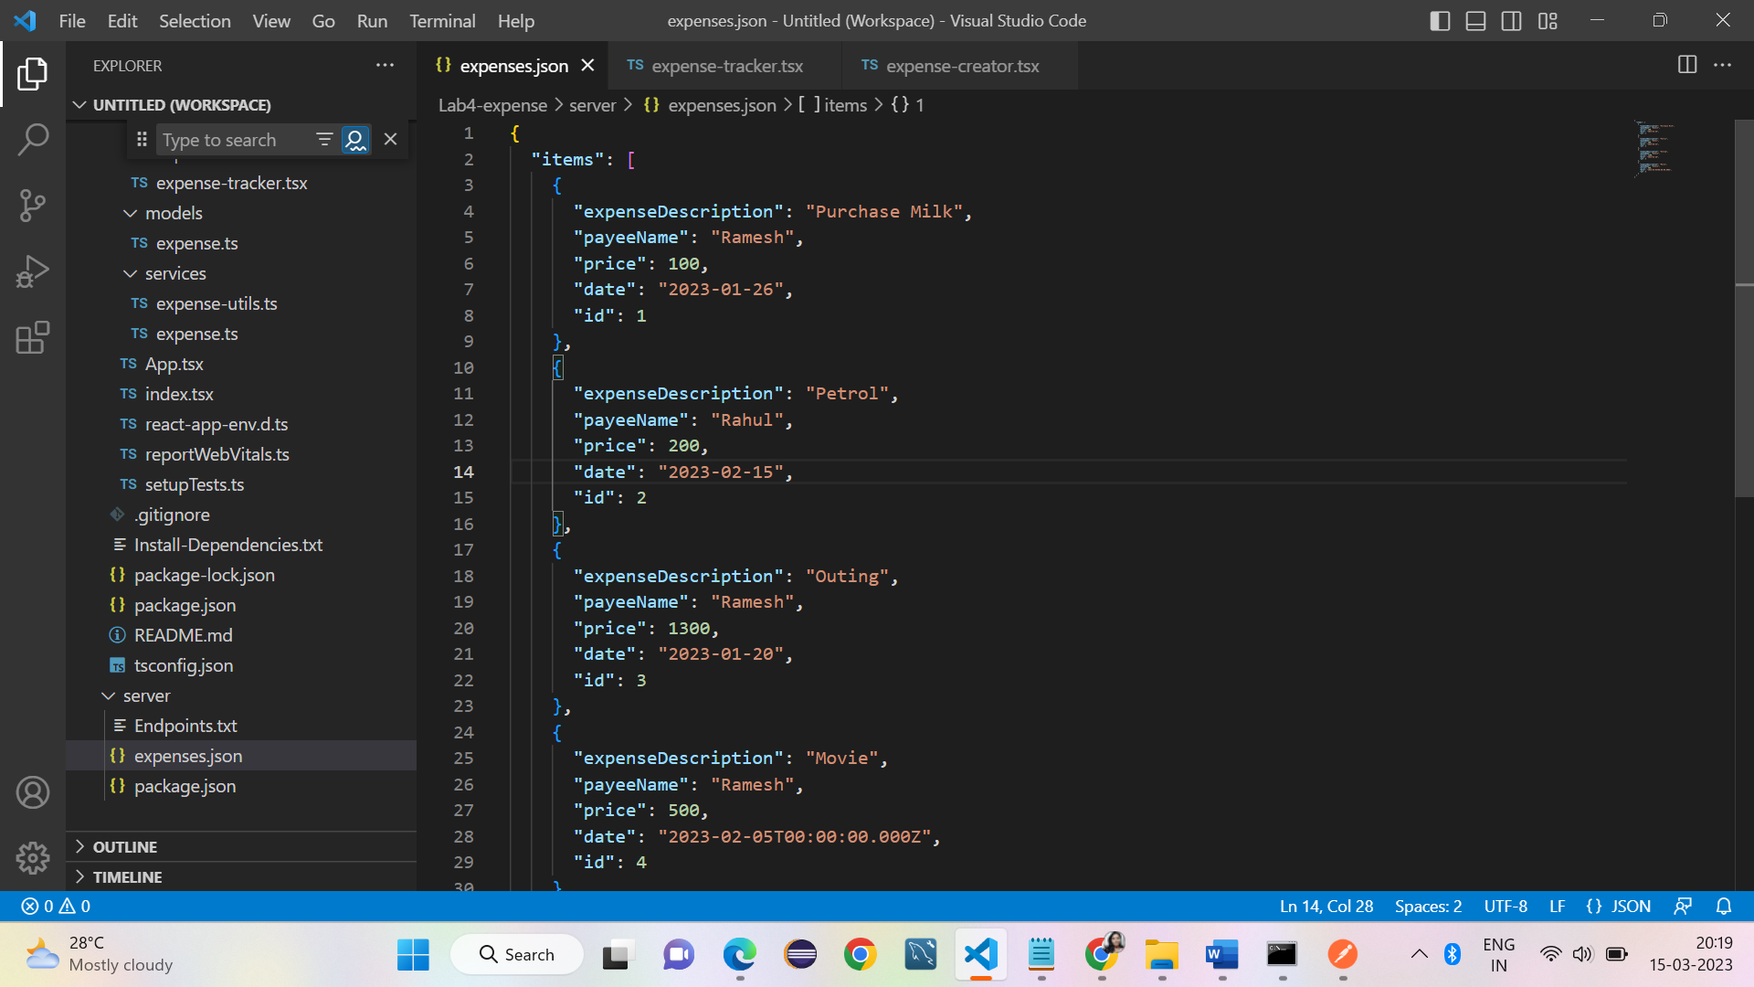

NPM commands run from command prompt

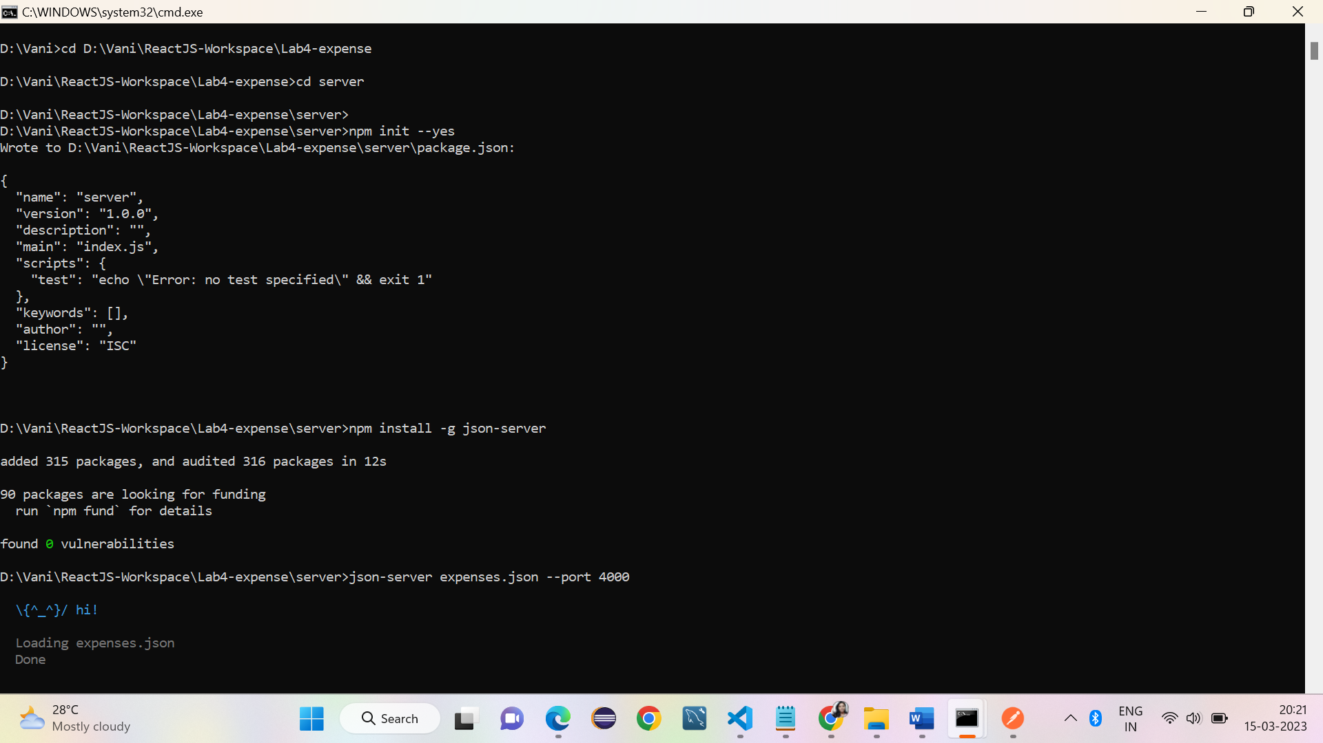

Command prompt for client app

Expense items from server hosted from local browser Server

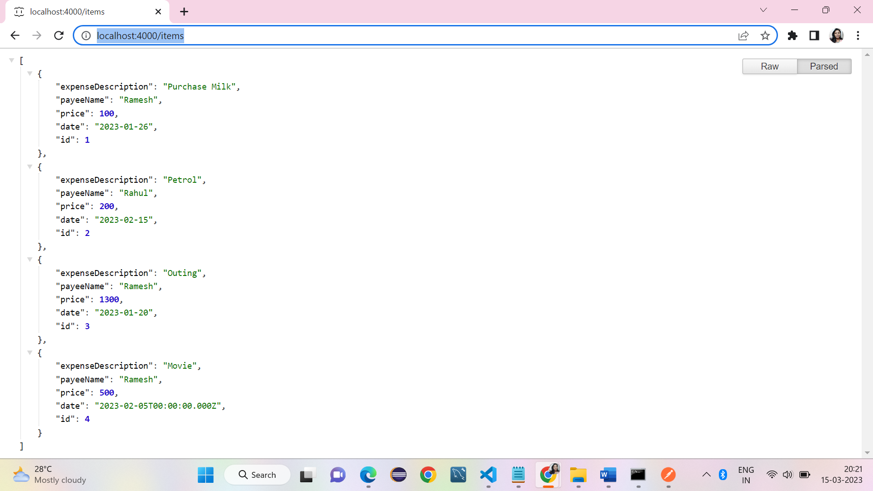

Expense Tracker App rendered from client local host, the initial 4 items are displayed.

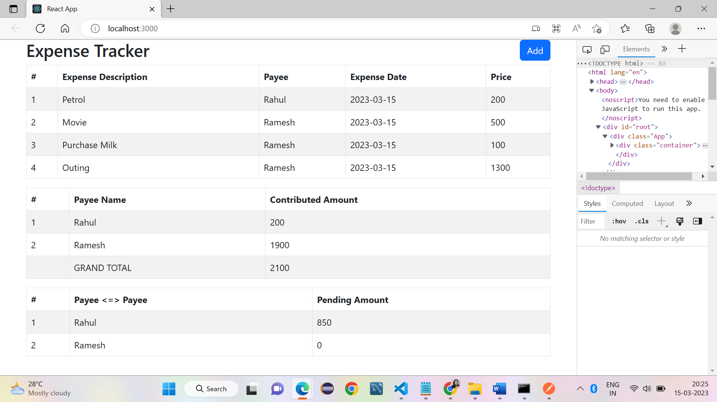

ADD expense item from the App

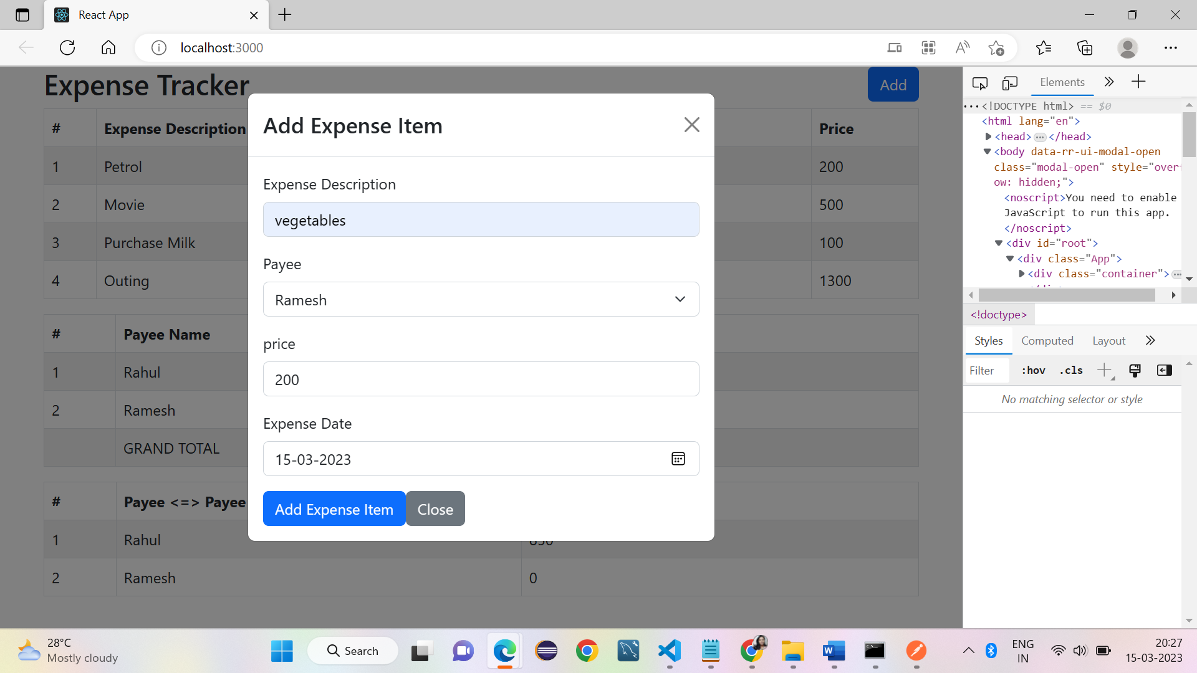

The new item ‘vegetable’ is added to the list and recalculated pending amounts.

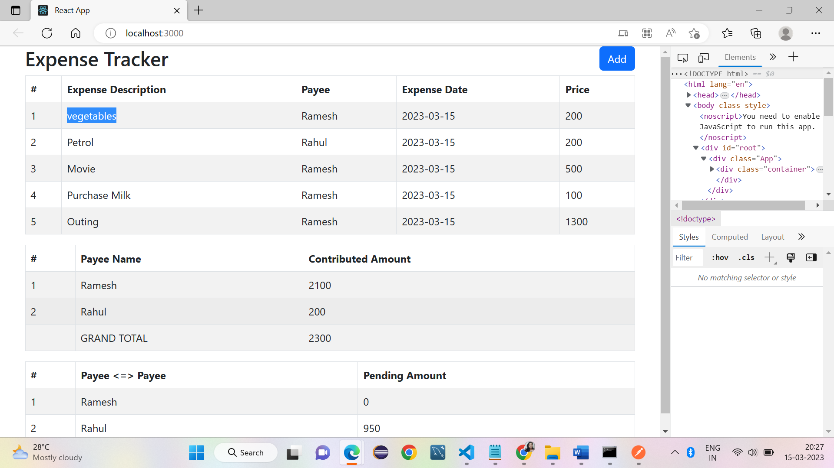

Same expense item is added automatically to JSON expenses item list file

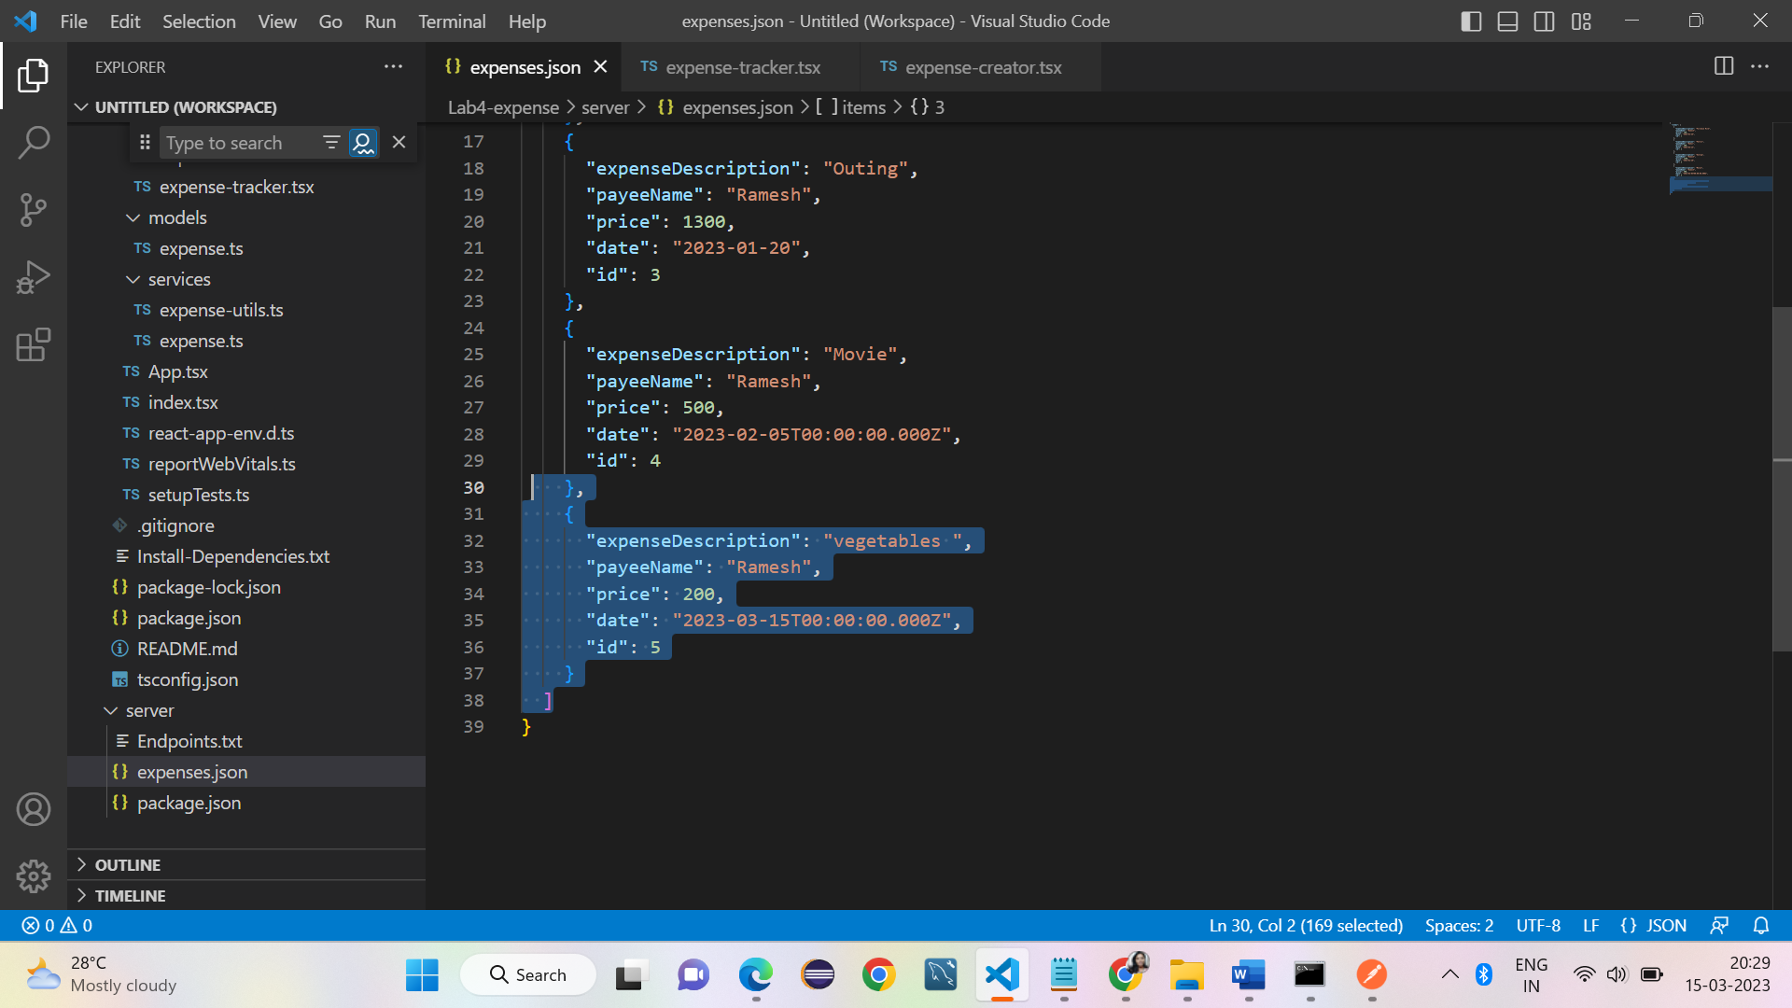

Postman query screens

